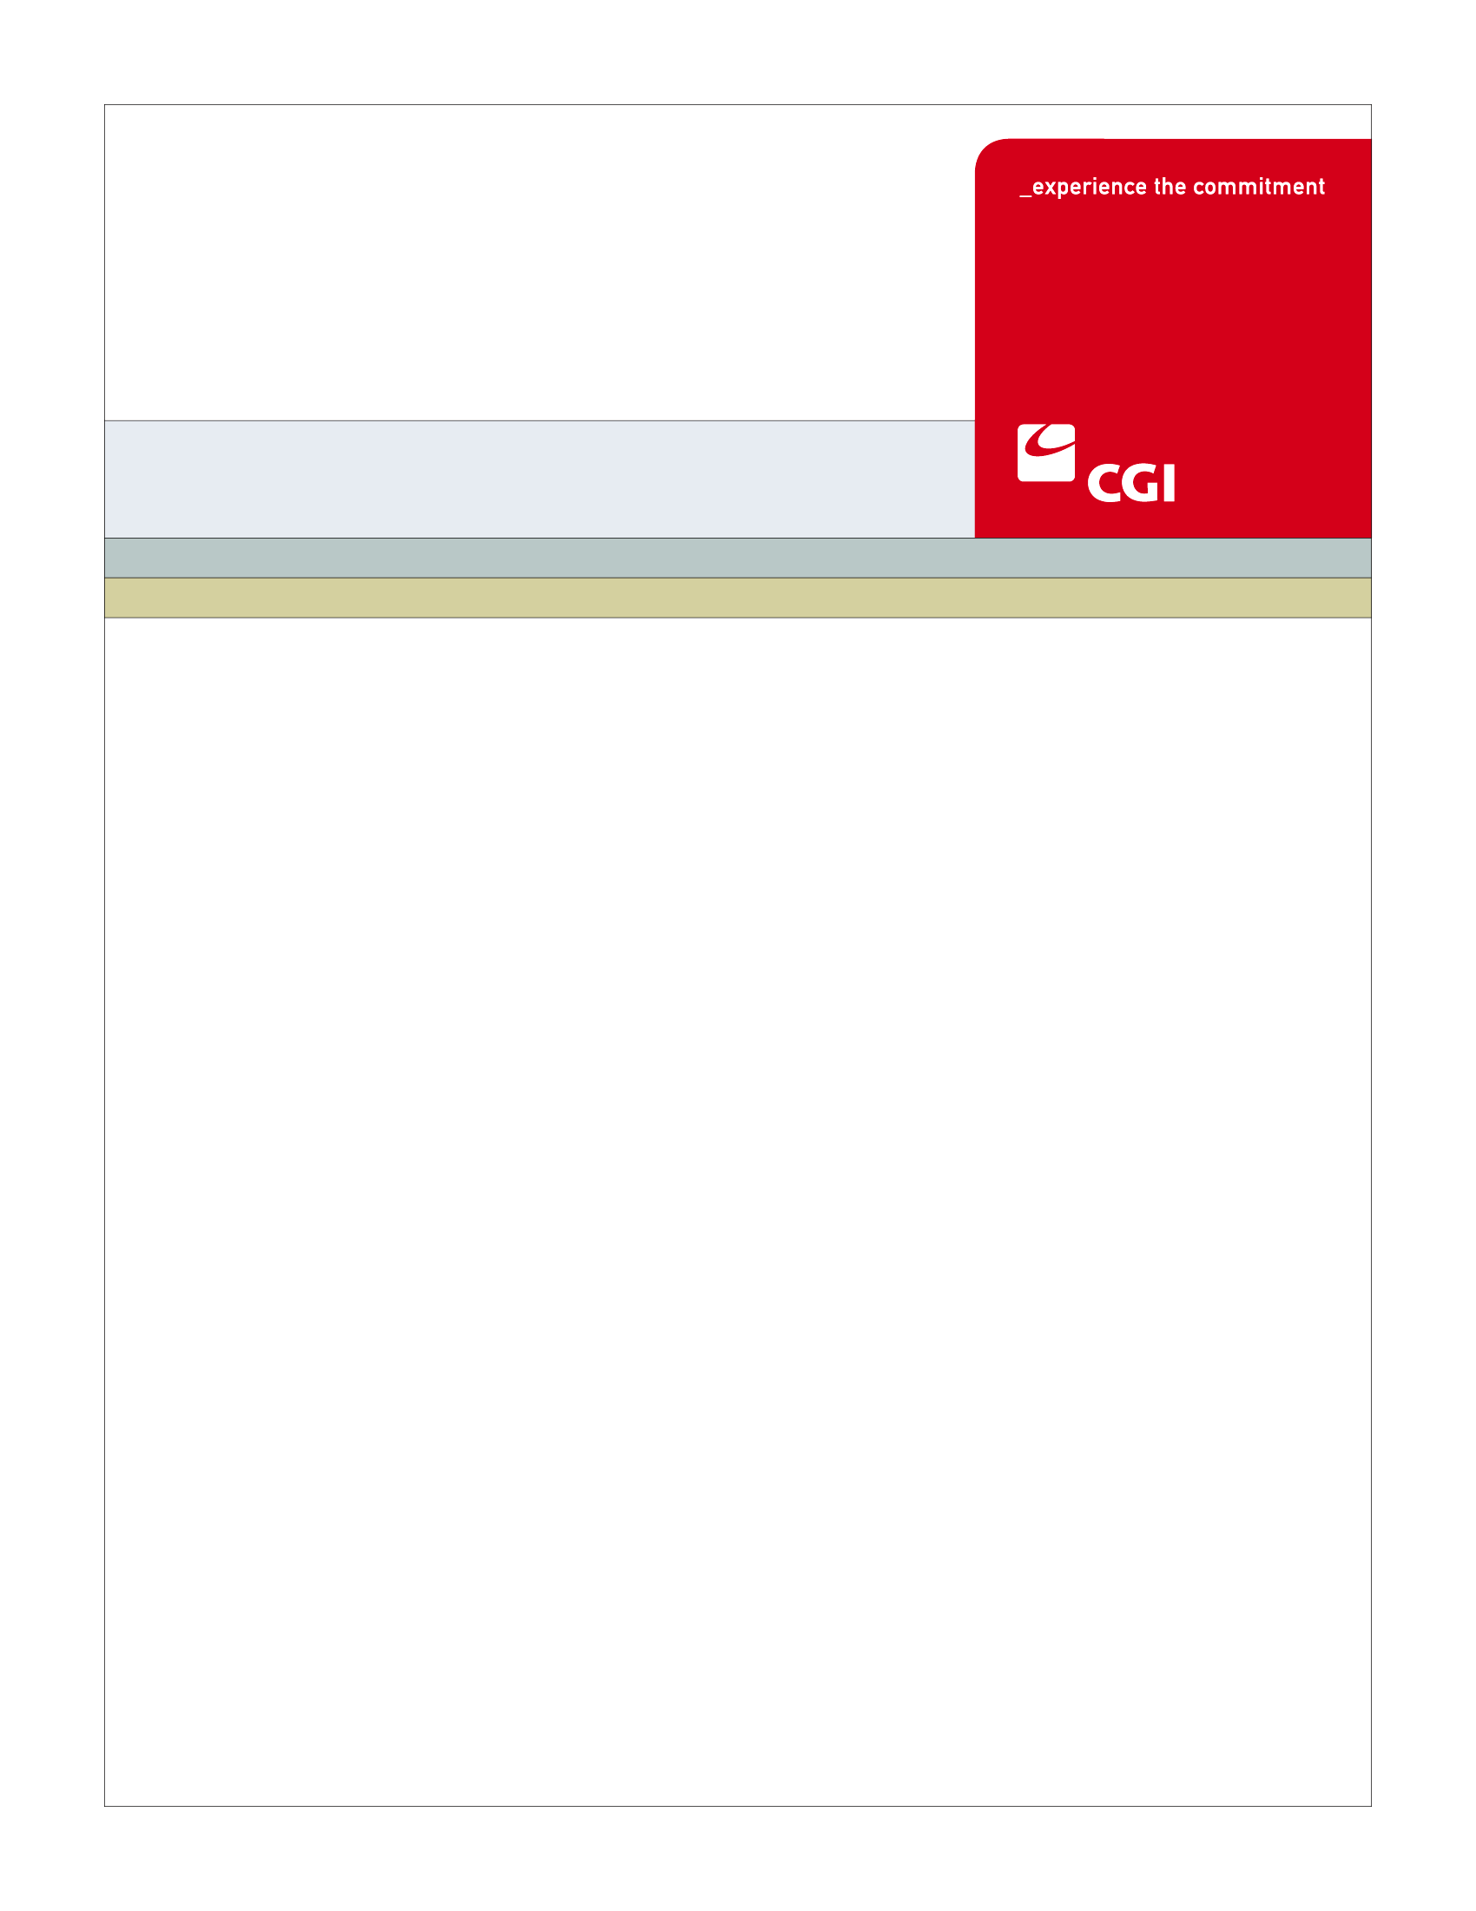

- USE
Colorado Health Benefit Exchange (COHBE)
Version 1.1
October 21, 2012
BN-002B Select Navigator Entity Use Case
REVISION HISTORY
Version | Date | Modified By | Description
0.1 | 2012-10-02 | Kevin Sudnik | Created new Use Case
0.2 | 2012-10-10 | Kevin Sudnik | Updated Use Case post-JAD Discovery
1.0 | 2012-10-21 | Kevin Sudnik | Updated Use Case post-JAD Elaboration
1.1 | 2012-10-23 | Kevin Sudnik | Updated Use Case post-JAD Verification

TABLE OF CONTENTS
1 Use Case: Select Navigator Entity 5
1.1 Goal 5
1.2 Brief Description 5
1.3 Requirements Traceability 5
1.4 Primary Actor 6
1.4.1 Employer 6
1.4.2 Individual 6
1.4.3 Service Representatives 6
1.5 Secondary Actor 6
1.5.1 The Exchange 6
1.5.2 Navigator Entity 6
1.6 Pre-Conditions 6
1.7 Successful Post-Conditions 7
1.8 Triggers 7
1.9 Assumptions 7
2 Flow of Events 8
2.1 Basic (Main) Flow – Select Navigator Entity 8
2.1.1 Does Customer Want to Filter Navigator Directory? 8
2.1.2 Enters Navigator Entity Filter Criteria and Clicks Filter 9
2.1.3 Retrieves List of Navigator Entities Meeting Filter Criteria 9
2.1.4 Exchange Certified Navigator Entities List 9
2.1.5 Views Filtered Navigator Entity Results 9
2.1.6 Does Customer Want to Contact Navigator Entity From Filtered Results? 9
2.1.7 Contacts Navigator Entity 9
2.1.8 Assigns a Navigator to a Customer 9
2.1.9 Next Steps 9
3 Alternate Flows 10
3.1 Views Unfiltered Navigator Entity Results 10
3.1.1 Views Unfiltered Navigator Entity Results 10
3.2 Continue Searching? 10
3.2.1 Is Customer Still Interested in Using a Navigator Entity? 10
4 Exception Flows 10
4.1 Next Steps 10
4.1.1 Next Steps 10
5 Specifications 11
5.1 Business Rules 11
5.1.1 Retrieve List of Certified Navigator Entities 11
5.2 Process Rules 12
5.3 Workflow 12
5.4 UI Screen Details 12
5.4.1 UI Flow Considerations 12
5.4.2 hCentive Navigator Entity Search Screen 12
5.5 Communications 12
5.5.1 Imaging Requirements 12
5.5.2 Form Requirements 13
5.5.3 Notices Requirements 13
5.5.4 Other Communication Requirements 13
5.6 Interfaces 13
5.7 Reporting 13
5.8 User Security 13
5.9 Activity Log and Audit Trail 13
6 Future Release Notes 14
Appendix A - Glossary 14

Use Case: Select Navigator Entity
When a customer enters the Exchange, with or without an account, and accesses the Navigator Entity directory, he or she can filter the results by entering filter criteria to locate a certified Navigator Entity to provide assistance with using the Exchange. The Navigator Entity’s listing on the Exchange can contain some of the various skills and expertise that the organization has as well as the entity’s contact information. The Navigator Entity can then assign a Navigator to assist the customer in using the Exchange.

Goal
The goal of the Select Navigator Entity Use Case is for a customer to be assigned a Navigator by a Navigator Entity to assist with using the Exchange.
This Use Case completes succesfully when a Navigator Entity has assigned a Navigator to assist the customer.

Brief Description
The customer enters the Exchange, with or without an account, and launches the Navigator Entity directory screen. The customer then enters Navigator Entity filter criteria and the Exchange retrieves the results. The customer then decides if he or she wants to contact the Navigator Entity to be provided assistance in using the Exchange. If yes, the Navigator Entity assigns a Navigator to the customer and the Use Case completes.

Requirements Traceability
The following requirements are covered within this Use Case:
- GF076: Service Representatives will be able to perform all of the activities of the System on behalf of Customers, should Customers need assistance or not have access to the System. Activities of Service Representatives will be limited to the functions required by their roles.
- IN090: The System shall contain a filterable and sortable directory of Navigator Entities containing contact information which can be accessed by customers.

Primary Actor

Employer
The Employer is a primary actor in the Select Navigator Entity Use Case. The Employer enters the Exchange and views and filters the Navigator Entity directory to find a Navigator Entity to assist with using the Exchange.

Individual
The Individual is a primary actor in the Select Navigator Entity Use Case. The Individual enters the Exchange and views and filters the Navigator Entity directory to find a Navigator Entity to assist with using the Exchange.

Service Representatives
The Service Representatives are a primary actor in the Select Navigator Entity Use Case. Service Representatives may only provide guidance to the customer on how to search for and contact a Navigator Entity.

Secondary Actor

The Exchange
The Exchange is a secondary actor in the Select Navigator Entity Use Case. Once the Employer or Individual has entered his or her Navigator Entity filter criteria, the Exchange retrieves the results and displays them on the customer’s screen.

Navigator Entity
The Navigator Entity is a secondary actor in the Select Navigator Entity Use Case. After the customer has contacted the Navigator Entity, the Navigator Entity assigns a Navigator to assist the customer with using the Exchange.

Pre-Conditions
The pre-conditions for the Select Navigator Entity Use Case are:
- The Establish Navigator Entity has been successfully executed at least once, so that Navigator Entity contact information has been loaded into the listing of certified Navigator Entities in the Exchange. The fields displayed in the Navigator Entity filter in this Use Case were populated when list was uploaded to the Exchange. These fields include:
  - Navigator Entity Listing Name
  - Navigator Entity ID
  - Phone Number
  - Navigator Entity Website URL
  - Navigator Entity E-mail address
  - About Us information provided by Navigator Entity
  - Street address
  - City
  - Zip code
  - Areas of Expertise
  - Areas of Service (Northwest, Front Range, Denver Metro, Northeast, Southeast, South Central, Southwest)
  - Languages supported
- At least one Navigator for the Navigator Entity that was created in Establish Navigator Entity has been certified to use the Exchange by the Certify Navigator Use Case.
- Customer has launched Navigator Entity directory from the Need Help screen that displays different avenues to seek assistance in using the Exchange (Provide Assistance to Customers Use Case).

Successful Post-Conditions
The successful post-condition for this Use Case is a Navigator is now assigned to a customer to provide assistance with using the Exchange.

Triggers
The Select Navigator Entity Use Case is triggered when the customer launches the Navigator Entity directory screen.

Assumptions
The Select Navigator Entity Use Case assumes the following:
- Navigator Entities have been awarded grants by COHBE to participate in the Exchange.
- Customers may or may not have an account set up prior to entering this Use Case.

Flow of Events
The Business Process Activity diagram below shows the COHBE processes for the Select Navigator Entity Use Case. The steps numbered on the diagram above have detailed explanations in the sections that follow.
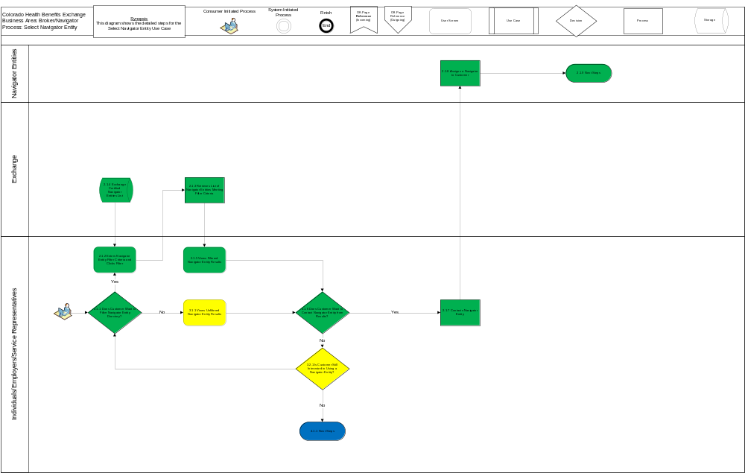

Basic (Main) Flow – Select Navigator Entity
The customer enters the Exchange and launches the Navigator Entity directory screen. The directory is pre-loaded with the full listing of Navigator Entities. The customer then enters any filter criteria and clicks filter. The customer then views the results and contacts a Navigator Entity if he or she wishes to. The Navigator Entity then assigns a navigator to assist the customer with using the Exchange.

Does Customer Want to Filter Navigator Directory?
The Employer or Individual decides if he or she wants to enter any filter criteria into the pre-loaded Navigator directory (Business Rule, Section 5.1.1).

Enters Navigator Entity Filter Criteria and Clicks Filter
The Employer or Individual enters his or her filter criteria into the Navigator Entity directory screen and clicks filter (Business Rule, Section 5.1.1).

Retrieves List of Navigator Entities Meeting Filter Criteria
The Exchange retrieves the list of Navigator Entities meeting the filter criteria entered by the customer (Business Rule, Section 5.1.1).

Exchange Certified Navigator Entities List
The Exchange contains the listing of Navigator Entities certified to use the Exchange.

Views Filtered Navigator Entity Results
The Employer or Individual views the results of the Navigator Entity filter.

Does Customer Want to Contact Navigator Entity From Filtered Results?
The Employer or Individual determines if he or she wants to contact the Navigator Entity to receive assistance with using the Exchange.

Contacts Navigator Entity
The Employer or Individual contacts the Navigator Entity. The Navigator Entity can be contacted via e-mail, phone, website URL, etc.

Assigns a Navigator to a Customer
The Navigator Entity assigns a Navigator to assist the customer with using the Exchange.

Next Steps
Next Steps for this Use Case include:
- The Navigator Support Use Case is initiated.

Alternate Flows

Views Unfiltered Navigator Entity Results
The customer views the unfiltered results of the Navigator Entity directory.

Views Unfiltered Navigator Entity Results
The Employer or Individual views the unfiltered Navigator Entity directory.

Continue Searching?
The customer decides if he or she wants to continue searching for a Navigator Entity to provide assistance with using the Exchange.

Is Customer Still Interested in Using a Navigator Entity?
The Employer or Individual decides if he or she wants to continue searching for a Navigator Entity to provide assistance with using the Exchange.

Exception Flows

Next Steps
After the customer has decided to not contact the Navigator Entity searched for in Steps 2.1.1-2.1.4 and also decides he or she does not want to continue searching for Navigator Entities, the Individual or Employer can then proceed to use the Exchange without the assistance of a Navigator.

Next Steps
Next Steps for the Exception Flow of the Select Navigator Use Case may include:
- The customer decides to continue using the Exchange without the assistance of a Navigator.

Specifications

Business Rules

Retrieve List of Certified Navigator Entities
When a customer enters his or her filter criteria into the Navigator Entity Search screen and clicks filter (Step 2.1.2), the Exchange will retrieve the list of Navigator Entities (Step 2.1.3) from the Certified Navigator Entity list (Step 2.1.4) meeting the filter criteria and displays the results on the customer’s user screen (Step 2.1.5).
Filter criteria for Navigator Entities will include the following:
- Navigator Entity Listing Name
- Areas of Expertise (can be a checkbox function - search for 2-3 at a time)
- Areas of Service (Northwest, Front Range, Denver Metro, Northeast, Southeast, South Central, Southwest)
- Languages supported (can be a drop down – search for 1 at a time)
Sort Criteria for Navigator Entities will include the following:
- Navigator Entity Listing Name
- City
Navigator Entity results to be displayed may include the following fields:
- Navigator Entity Listing Name
- Navigator Entity ID
- Phone Number
- Navigator Entity Website URL
- Navigator Entity E-mail address
- About Us information provided by Navigator Entity
- Street address
- City
- Zip code
- Areas of Expertise
- Areas of Service (Northwest, Front Range, Denver Metro, Northeast, Southeast, South Central, Southwest)
- Languages supported

Process Rules
There are no process rules associated with the Select Navigator Entity Use Case.

Workflow
There is no workflow associated with the Select Navigator Entity Use Case.

UI Screen Details

UI Flow Considerations
The customer’s user interface should display the results of the search after the search criteria have been entered into the user screen and the customer has clicked search.

hCentive Navigator Entity Search Screen
hCentive will provide a directory of Navigator Entities that will allow search criteria to be entered for the purpose of filtering the results.
Fields that will be included on the hCentive Navigator Entity Directory Screen include:
- Navigator Entity Listing Name
- Navigator Entity ID
- Phone Number
- Navigator Entity Website URL
- Navigator Entity E-mail address
- About Us information provided by Navigator Entity
- Street address
- City
- Zip code
- Areas of Expertise
- Areas of Service (Northwest, Front Range, Denver Metro, Northeast, Southeast, South Central, Southwest)

Communications

Imaging Requirements
There are no imaging requirements associated with the Select Navigator Entity Use Case.

Form Requirements
There are no form requirements associated with the Select Navigator Entity Use Case.

Notices Requirements
There are no notices requirements associated with the Select Navigator Entity Use Case.

Other Communication Requirements
Service Representatives will need regional maps of Colorado to assist customers with using the Navigator Entity Directory.

Interfaces
There are no interface requirements associated with the Select Navigator Entity Use Case.

Reporting
Reports associated with the Select Navigator Entity Use Case will have the following attributes:
- How many clicks link to Navigator Entity directory (Potential report).
- How many times e-mail link clicked (potential report).
- Statistics on areas of expertise selected.
- Statistics on languages selected.
- Statistics on Areas of Service selected.
- Statistics on Navigator Entity Listing Names selected.

User Security
There are no user security requirements associated with the Select Navigator Entity Use Case.

Activity Log and Audit Trail
This Use Case has the following Activity Log and Audit Trail considerations:
- How many times users have clicked on Navigator directory link.
- How many times users have clicked on e-mail link.

Future Release Notes
There may be a pre-populated e-mail to be sent to the Navigator Entity launched from the Navigator Entity directory by the customer.
Displaying consumer satisfaction comments/ratings of Navigator Entities.
Filtering for Navigator Entities within X miles of a zip code.
A Map within the Navigator Entity directory.

Appendix A - Glossary
Term | Definition
Account | An “Account” is the means by which a user can access a computer system
Activity Log | An “Activity Log” is a chronological record of every action taken by each user, and by the System on behalf of each user. The activity log includes actions and events pertaining to transactions, workflow, security (including SIEM), Alerts, Notifications, Approvals and interactions between the user and the System such as submissions of forms, data and documents.
Audit Trail | An “Audit Trail” is a subset of records in the Activity Log that are selected and correlated by criteria provided by the auditor or requesting authority.
Authorization | “Authorization” is confirmation by a higher or secondary authority of the validity of an action taken by either a lower or primary actor of workflow on the System
COHBE | Colorado Health Benefit Exchange, “COHBE” is used interchangeably with “Exchange” throughout the documents.
Customer | “Customers” or “Consumers” may be used interchangeably and are terms meant to define individuals or small employers or employees of small employers learning about opportunities to purchase, shopping to purchase, purchasing insurance through the Exchange, or modifying insurance purchased through the Exchange. References to Customers include, as appropriate, dependents of Customers, employees and dependents of employees and others covered by insurance purchased by Customers through the Exchange.
Employer | An “Employer” is a company or small business who participates in the Exchange to offer insurance and/or premium assistance to its Employee(s) or its Employee(s) and their dependents.
Exchange | During the implementation phase, the terms “Exchange” or “Exchanges” are meant to include technology, services, business processes, people, and other resources required to implement, operate and/or maintain the requirements or functions needed to support the ability for consumers to shop for and purchase health insurance. Specifically related to interpretation of a requirement, the term “Exchange” implies that the implementation of a requirement is not strictly limited to a technology solution.  - Individually, the term “Exchange” refers to each Exchange or both Exchanges as appropriate in the context.  - The Exchange is NOT a state agency but a standalone non-profit entity. It will serve as an aggregator of individual policies sold by private insurers and underwritten using the new federal and state underwriting and rating rules.  - The Small Business Health Options Program (SHOP) Exchange will support the specific needs of small employers.  - For context, the Exchanges will act much like an “Expedia or Orbitz for Health Insurance” system. They will allow individuals and small firms to obtain information, compare and purchase private health insurance plans. The Exchanges will also be the entities that will evaluate whether or not a particular insurance policy meets the criteria set out by the new federal rules for policies offered to individuals and small employers.
Navigator Entities | “Navigator Entities” are organizations that employ resources either as employees or volunteers who provide authorized assistance to customers as they shop for insurance through the Exchanges.
Navigators | “Navigators” are persons authorized to assist Customers in their activities to shop for insurance through the Exchanges.
Service Representatives | Service Representative (ServRep or SR): A COHBE representative who assists Participants, Customers, and/or Users in using the Exchange and/or the System. NOTE: CSR is used to mean Cost Sharing Reductions and shall not be used to mean ‘customer service representative’.
System | The “System” means all of the software, configurations, data, processes, and equipment used to provide the Exchanges and the System is also referred to as the “solution.” During the implementation phase, “System” is taken to mean the technology component of the Exchange.
Users | “Users” are users of the Exchange authorized by COHBE and may include operators, administrators, customers, brokers, navigators, etc., who interact with the System. Users may be internal or external to COHBE.

